Recycling Modernisation Fund
Regional & Remote Communities
Recycling Infrastructure Grants

Guidelines

November 2021

Recycling Modernisation Fund: regional and remote funding - Guidelines for Commonwealth co-investment

Introduction
In March 2020, the Prime Minister announced the Australian Government will co-invest in critical recycling infrastructure along with state and territory governments, and industry. The $190 million Recycling Modernisation Fund (RMF) was established to improve recycling infrastructure by addressing infrastructure gaps in Australia’s waste management and resource recovery system. The RMF focuses on the waste streams impacted by the Council of Australian Governments’ Export Waste Ban (on unprocessed glass, mixed and single polymer plastics, tyres, and mixed paper and cardboard). The RMF jointly funded with states and territories through the National Partnership on Recycling Infrastructure.
High capital costs to install modern technology, volatile international markets, and long and expensive planning approvals make attracting investment for recycling solutions a challenge. Managing waste in regional and remote locations throughout Australia presents additional challenges. Isolation during the wet season or as a result of natural disasters, lack of connection with major transport routes, no or limited kerbside collection and long distances to recycling and remanufacturing centres all present considerable logistical and financial complexities. Legacy waste, human health and financial impacts to communities are additional issues in regional and remote areas.
A key target of the 2019 National Waste Policy Action Plan (the National Action Plan) is to achieve an 80 per cent average resource recovery rate from all waste streams following the waste hierarchy by 2030. To achieve this target, the National Action Plan recognises that regional and remote areas require better access to waste management and processing. To help reach this target, under the RMF, the Australian Government will co-fund projects that increase the sorting, processing, and manufacturing or remanufacturing capacity of regional and remote locations. The areas of interest for this funding are all non-metro areas falling under the ABS classifications of inner and outer regional, remote and very remote areas.
To assist with identifying regional and remote areas, the Australian Bureau of Statistics (ABS) uses the Accessibility/Remoteness Index of Australia (ARIA+). A map of the 2016 census data showing Remoteness Areas is outlined in Map 1.
Map 1 - Map of the 2016 Remoteness Areas for Australia
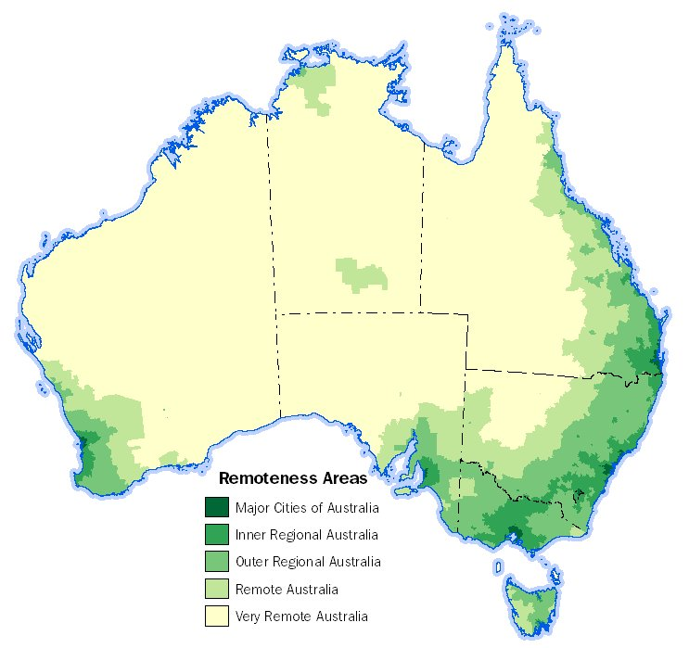
Source: ABS website

About Green Industries SA
Green Industries SA is an enabler and driver of change, supporting the development of the circular economy through diverse collaborations which improve productivity, resilience, resource efficiency and the environment. It aims to transform how South Australians use and value resources. Its objectives under the Green Industries SA Act 2004 are to:
- promote waste management practices that, as far as possible, eliminate waste or its consignment to landfill; and
- promote innovation and business activity in the waste management, resource recovery and green industry sectors, recognising these areas present valuable opportunities to contribute to the state’s economic growth.
For more information visit www.greenindustries.sa.gov.au.

South Australia’s Waste Strategy
The Recycling Modernisation Fund Grant Program responds to changes brought about by the Council of Australian Governments (COAG) ban on the export of certain wastes. Initiatives funded through the program will support South Australia’s Waste Strategy 2020-2025 which outlines actions that can contribute to the development of a circular economy in South Australia through:
- a clearly articulated policy and legislative framework that gives a solid platform for investment decisions and a stable and efficient market
- supporting innovation and commercialisation
- education, advocacy and awareness to support behavioural change in the way waste and resources are managed
- applying the waste management hierarchy consistently with the principles of ecologically sustainable development.

Project Information
Projects that provide local solutions to local problems, seek to increase local employment, provide economic benefit, and solve transport logistic complexities will be highly regarded. Applicants are invited to submit proposals for economically viable projects that best address regional pressures. Projects that support connections between local organisations in remote and regional areas and major companies in urban areas of Australia are encouraged to close-the-loop between waste generation, sorting, processing, remanufacturing, and input back into the economy. Applicants may wish to communicate with their local Regional Development Associations when developing proposals.
Small organisations, such as small and medium businesses, not-for-profits, Local Government, community groups, regional research institutions and Traditional Custodians are encouraged to apply. Eligible proposals from small organisations may be further assessed through the Small organisations supporting points assessment.

Application process
Date | Event
18 November 2021 | Applications open
4 January 2022 | Applications close
End January 2022 | Green Industries SA assessment process completed
Early February 2022 | Recommended projects submitted to Commonwealth for consideration
End March 2022 | Commonwealth decision on successful Round 2 projects

Aim of the Recycling Modernisation Fund Grants Program
The Recycling Modernisation Fund Grants Program (the program) assists private sector, non-government organisations and, local government organisations to install infrastructure and provide innovative approaches to increase the supply of quality recycled materials available for use, and increase the capacity for domestic sorting, processing and manufacturing of materials affected by the COAG waste export bans. The program encourages applications for infrastructure projects that will contribute to achieving these outcomes and include economic, environmental and social benefits.
The program focusses on investments that position Australia to meet its future waste challenges and aims to deliver on key priorities at a national level.
Grants are intended to:
- support the development of new or upgrading of existing infrastructure and/or equipment to enable remanufacturing/value adding of eligible material streams for local use (preferred); or
- allow for improved sorting and/or processing to enhance recoverable material quality through reduced contamination levels for local use or entry into local and export markets, noting the requirement to meet export ban specifications and/or criteria arising from the COAG bans.

Available funding and applicant co-contribution
Recycling Modernisation Fund Grants offered through this program represent a combined contribution from both the South Australian and Commonwealth governments. Applications for funding from $20,000 to a maximum of $500,000 will be available, for large scale projects involving significant capital expenditure and of state significance.
Applicants are required to provide a minimum cash contribution of 50% of the requested grant amount, being 1/3 of the project cost (1:1:1 funding).
Applicants that include a cash co-contribution of greater than 50% of the requested grant amount will be viewed favourably, as this will maximize the State and Commonwealth government’s return on investment.

Eligibility criteria
Application forms are attached to these guidelines. Applications will need to meet the following criteria:
- Must be submitted to the Australian government by a state or territory government and have written support of the responsible minister and must contain a commitment from the state or territory to match Commonwealth funding. Proposals must also include a third party (such as business, local governments, or non-government organisations)
- Projects must be consistent with Appendix A of the National Partnership on Recycling Infrastructure. Examples of potential projects may include:
- Community sorting stations or baling equipment;
- Install new equipment such as sorting lines, AI or scanning technology, or pulping machinery;
- Breaking down e-waste into plastics and glass for recycling;
- Advanced recycling of hard-to-recycle plastics, such as mixed, multi-layer, flexible or contaminated plastics back into food grade recycled plastics or other products through chemical, thermal or biological processes;
- Recycling of glass and plastics for use in road, footpath, cycleway or rail products;
- Breaking down all components of waste tyres into new tyres and products, or for further recycling;
- Trials for remanufacturing of plastic, glass and other material into building products;
- Recycling of non-hazardous medical waste, such as plastic waste generated by a hospital;
- Projects (including trial projects or multi-location projects) that include improved collection of feedstock, preparing it for collection near main routes, for further processing, recycling and re-manufacturing at a major location;
- Community and local organisations driven projects, with identification of a problematic waste item in their area (for example: bread tags, straws, face masks and other), collection of such items and production of a bench seat (or similar);
- Recycling of agricultural plastics, irrigation pipes and other drought infrastructure which can be recycled.
- Proposals must seek to deliver a project or trial to build new, or increase existing capacity, in a regional or remote location through:
  - proposed new fixed or mobile facilities, or expansion of existing fixed or mobile facilities for the processing of recovered unprocessed glass, mixed or single resin/polymer plastics, tyres and/or paper and cardboard; and/or
  - provide new or upgraded equipment to increase local domestic processing capacity for recyclable materials, including from point of collection to point of remanufacturing; and/or
  - increase use of recyclable or recycled materials in manufacturing and/or infrastructure.
- Proposals must demonstrate how the proposed project is expected to be economically viable over its operational life post-RMF.
- Proposals should support employment and long-term economic growth and development in regional and/or remote location/s. Projects may rely on further infrastructure located in major city areas, but funding must primarily address recycling challenges and create economic benefit in regional and/or remote locations.
- Any projects partner(s), including local government council or associations, will need to demonstrate the project partner has a current Australian Business Number (ABN), is registered for GST, is not insolvent, has not been convicted of contravening environment protection legislations in the last five (5) years, does not have owners/directors who are an undischarged bankrupt and has a business plan in place for the project proposal.
- The Australian Government acknowledges that jurisdictions have different policies on energy from waste projects. For the purposes of RMF funding, the Australian Government considers that projects may be eligible if the project primarily produces recovered products that contribute to a circular economy, and energy is a by-product and not a major output of the process. Examples may include advanced recycling projects, which are also referred to as feedstock, molecular, or chemical recycling, and which converts plastic waste into its chemical building blocks and back into plastic, creating high value output for input back into the circular economy. Energy from waste projects are not eligible for funding under the RMF.
- Project proposals that involve small organisations in remote or very remote areas are especially encouraged. Small organisations include: small to medium businesses, Local Governments, not-for-profits, social enterprises, community groups, regional research institutions, Aboriginal Land Councils or similar. Eligible proposals may classify to be further assessed and possibly score additional points through the Small businesses supporting points assessment.
- Projects should be complete by 30 June 2024 to meet the waste export bans as they are phased in.

Privacy and commercial-in-confidence considerations
All applications will be treated as commercial-in-confidence. Green Industries SA reserves the right to include third party evaluations as part of the assessment process. The South Australian Government and Commonwealth Government have the ultimate discretion in relation to publicity for successful applications. Applicants are not permitted to publicise their projects without the approval in the first instance of Green Industries SA, who will liaise with the Commonwealth Government accordingly.

Insurance
For the duration of the project, the proponent must maintain workers compensation insurance, public liability insurance for a minimum of $10 million per claim and personal accident insurance of $100,000 per participant.

Funding agreement
Successful applicants will be required to enter into a funding agreement with the South Australian Government (Green Industries SA). This agreement will set out the terms of the grant, conditions, payment schedules, project timing, key performance indicators, reporting requirements and other matters.
The South Australian Government and Commonwealth Government must be acknowledged in all media and promotional activities relating to the project. All publicity must be approved in the first instance by Green Industries SA, who will liaise with the Commonwealth Government accordingly. A copy of a standard funding agreement can be provided on request.
The funding agreement must be signed within 30 days of receipt to guarantee the grant acceptance.

Reporting
Following commissioning of equipment Green Industries SA requires successful applicants to provide reports, usually after six to 12 months, however this will be determined on a case by case basis and in accordance with Commonwealth Government requirements. Reports will require information on products received for processing and the material types, processing outputs (tonnes), jobs created both during construction and operation. Reporting and payment milestone timelines will be agreed with the applicant before funding is offered and included in funding agreements.

Assessment criteria
Applications will be assessed with reference to the weighting against each criterion as outlined on the following table.
Criterion No. | Criterion | Weighting
 | Proposed project must demonstrate that it will address regional and/or remote resource recovery challenges,  Proposed project should demonstrate that it is part of a solution for sorting, processing, re-manufacturing or selling, and/or transport of recovered glass, plastics, tyres, and/or paper and cardboard in regional and remote locations.  Proposed project addresses critical gaps in capacity. This includes whether:  - the project is expected to absorb glass, plastics, tyres or paper/cardboard from regional or remote locations that would typically be exported from Australia, or would end up in landfill, and  - the project’s location has access to the transportation and distribution networks in the relevant regional and/or remote location. | 30 points
 | Proposed project is supported by an overall business case, planning and regulatory requirements to proceed to construction are identified, evidence is provided on the process for gaining approvals, and project is expected to be economically viable over its operational life. | 20 points
 | Proposed project will create higher-value feedstock or offtake for remanufacturing products for which a suitable level of demand is expected. Identification of end-markets will be highly regarded. | 15 points
 | Proposed project will support small and local businesses, employment and long-term economic growth and development in regional and/or remote location/s. | 15 points
 | Project is in Remote Australia or in Very Remote Australia in accordance with the ABS remoteness classification | 5 Points
 | Proposed project is unlikely to proceed without assistance from the Australian Government or will only proceed at a much later date or much lower scale. | 5 points
 | Proposed project has a clear and credible plan to fully engage and consult affected stakeholders, traditional custodians and communities. | 5 points
 | Projects will be fully operational by 30 June 2024 | 5 points

Small Organisations Supporting Points Assessment (only small organisations are eligible to receive points under these criteria)
 | Proposed project is a small organisation with experience operating in the location of the proposed projects. | 5 points
 | Proposed project will create at least two ongoing jobs. | 5 points
 | Project connects local businesses, builds partnerships, and supports local supplier hubs | 5 points

Glossary
Reference | Description
Legacy waste | Accumulated waste over a long period of time, disposed of on land, with no final destination or purpose. Legacy waste can be unsorted, untreated and stockpiled waste with no environment protection controls applied.
Small and medium businesses | The Department of Industry, Science, Energy and Resources identifies small to medium businesses as those businesses who carry on an enterprise in Australia, have less than 200 employees and have an ABN.

